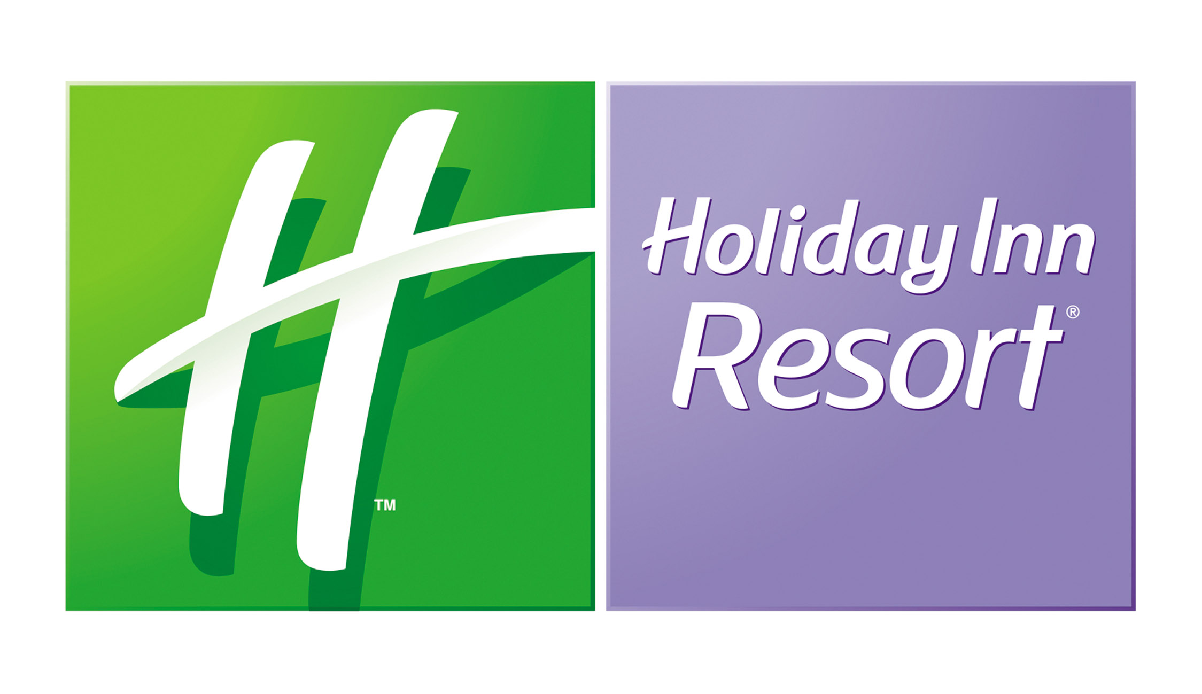

Area Shuttle Schedule
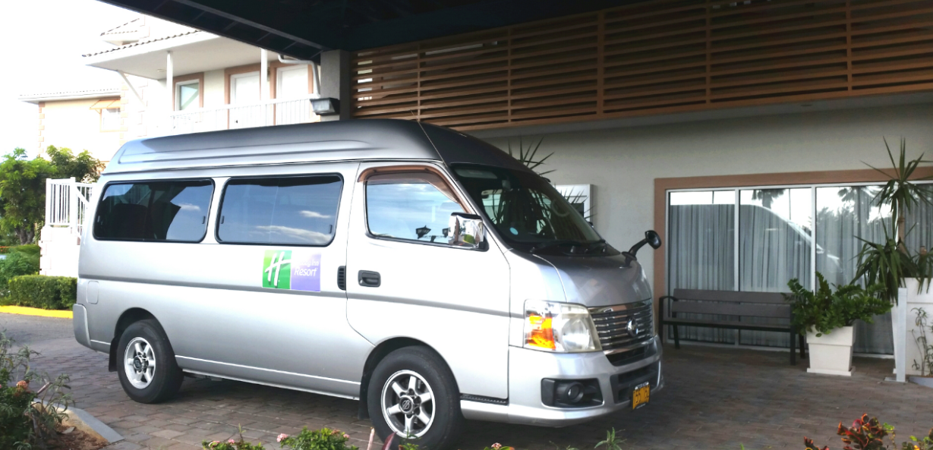
December 24th to January 6th 2019- 9am – 9pm
January 7th 2019- May 15th 2019
- Friday and Saturday- 9am to 8pm
- Sunday to Thursday- 9am to 6pm
May 16th to December 23rd
Pick up/drop off locations.
- Fosters Food Fair- West Bay Road
- Camana Bay- Town Centre
- George Town- Cruise Ship Terminals
- Public Beach
- Sunday to Friday- 10am to 6pm
- Saturday- 10am to 8pm
Shuttle can be booked by visiting the front desk to sign up or by dialing “0” from your room.
Driver names; Lloyd & Tevita.


